

NEMA (Non-Entitlement Matching Algorithm)
Business Requirements
(WR# 6398)

Prepared By: Raghuram Tirumalasetti
Last Modified: 10th August 2009

Approved By:

______________________
Anthony Montesano
Trading Operations Division

______________________
Mark Novak
Systems Division

Review Version
CBOE Confidential & Proprietary
Table of Contents

1 Introduction 3
1.1 Background 3
1.2 Business Goal 3
2 Business Requirements 4
2.1 General Assumptions 4
2.1.1 Assumptions 4
2.1.2 Dependencies 4
2.2 A New Allocation Trade Type 5
3 Appendix 7
3.1 'Non-Entitlement with Cust Joiners’ 7
3.1.1 'Non-Entitlement with Cust Joiners’ is not applicable for New HAL 7
3.1.2 'Non-Entitlement with Cust Joiners’ is not applicable when Customer is FIRST in time 7
3.1.3 'Non-Entitlement with Cust Joiners’ is applicable when Customer is not FIRST in time 8
3.1.3.1 Simple Order trading with book 8
3.1.3.2 Strategy Order trading with legs after COA 8
3.1.3.3 Strategy Order trading with COB after COA 9
4 Open Issues/Questions 10

Introduction

Background
With CBOE implementing Customer Priority as part of the default allocation strategy at times the PDPMs and MMs are being disadvantaged in trade allocations when a Customer Order steps in the last instance and takes away the full quantity of the incoming order at that price point. Hence there has been an attempt to curb those professional customers from taking advantage in the last instance over the PDPMs and MMs, by creating a new allocation algorithm that restricts customer entitlements if they are not FIRST in time at that price point.

Business Goal
The goal of the NEMA (Non-Entitlement Matching Algorithm) Project is to create a new Allocation Trade Type for restricting customer entitlements if they are not FIRST in time at that price point

Business Requirements

General Assumptions

Assumptions

- The Allocation Trade Type of REGULAR (0) is fully configurable but for initial implementation and testing purposes would be considered to be set as follows
  - Default Strategy Code : Price Time (1)
  - Prioritized Strategy Codes : Customer (4), Preferred DPM with Pct. (20)
- The Allocation Strategy Code of Customer (4) will consider the order origins configured in Order.xml like <customerCodes>C,D</customerCodes>
- The Allocation Strategy Codes of Market Turner (5) or Pro Rata (2) do not have any customer priority or any DPM/eDPM/PDPM participation rights in their evaluation
- There will be only one PDPM at a price point
- The new Allocation Trade Type of ‘Non-Entitlement with Cust Joiners’ will not be applied
  - for PAR initiated requests like T/A or T/B
  - for auction trades in New HAL, SAL, AIM, COA

Dependencies

- The Preferred Entitlements for Complex Orders (WR #6231) Project will be implemented in production

A New Allocation Trade Type

- In the Trading Property of ‘Allocation Strategy’ a new Allocation Trade Type called ‘Non-Entitlement with Cust Joiners’ must be created and it must be fully configurable with various Allocation Strategy Codes
  - For initial implementation and testing purposes the default setting would be either of the following
    - Default Strategy Code : Pro Rata (2)
    - Prioritized Strategy Codes : No Value / None

or

    - Default Strategy Code : Pro Rata (2)
    - Prioritized Strategy Codes : Market Turner (5)
  - The choice for configuring Market Turner + Pro Rata or just Pro Rata must be available by Session by Class and must not be tied in any way to the ‘Regular’ Allocation Trade Type configured for that class

- The newly configured Allocation Trade Type of ‘Non-Entitlement with Cust Joiners’ must be applied at a price point if there is a Customer Order on the market that is not FIRST in time at that price point

- The ‘Non-Entitlement with Cust Joiners’ Allocation Trade Type must be applicable
  - Only during ‘Open’ and ‘Fast’ product states
  - Both for Simple and Strategy Orders (i.e. both Complex and Cross Product Spreads)
  - Only for non-auction allocations
  - Only when the resting Customer Order which is not FIRST in time at that price is also not a Volume Contingency Order
  - Even for ‘Five Lot or Less Allocations’ which is triggered using the Trading Property ‘Allocate all to Opposite side rights participant’
  - Also for Strategy Orders that are COAed but only partially traded during COA and then the remainder is booked resulting in trades either with the CBOE leg book or the COB

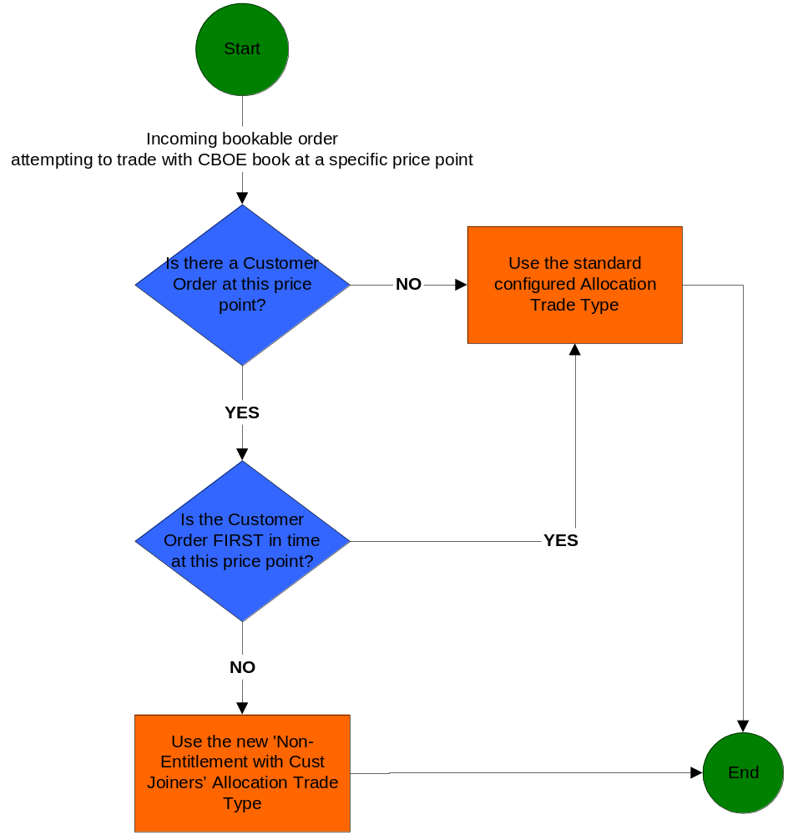

(Note: For examples, refer Appendix below)

- Currently whether to apply 5 lots DPM allocation or not is checked at each price point. So for an incoming order with 5 lot or less quantity the ‘Non-Entitlement with Cust Joiners’ Allocation Trade Type must be applicable when both the conditions below are met.
  - there is at least one DPM or PMM on the opposite side of the incoming tradable and
  - the Trading Property ‘Allocate all to opposite side rights participant’ has the values of either Allocate All to PMM (1) or Allocate All to PMM based on Rights Scales (2)

- For an incoming order with 5 lot or less quantity when the ‘Non-Entitlement with Cust Joiners’ Allocation Trade Type is applicable then the acceptable strategy codes are
    - Default Strategy Code : Pro Rata (2)
    - Prioritized Strategy Codes : No Value / None

or

    - Default Strategy Code : Pro Rata (2)
    - Prioritized Strategy Codes : Market Turner (5)
(Note: If anything other than those two strategy codes are configured then the system must always default to use the Default Strategy Code: Pro Rata (2) and Prioritized Strategy Codes: No Value / None)

Appendix

Let us assume that
- The Allocation Trade Type of REGULAR (0) (referred here as REGULAR) is configured as follows
  - Default Strategy Code : Price Time (1)
  - Prioritized Strategy Codes : Customer (4), Preferred DPM with Pct. (20)
- The Allocation Trade Type of ‘Non-Entitlement with Cust Joiners’ (referred here as NEWALLOC) is configured as follows
  - Default Strategy Code : Pro Rata (2)
  - Prioritized Strategy Codes : Market Turner (5)

'Non-Entitlement with Cust Joiners’

'Non-Entitlement with Cust Joiners’ is not applicable for New HAL

Step # | Action / Result
1 | NBBO is 1.00 – 1.10 (100 x 100)  CBOE is 1.00 – 1.20 (200 x 200)  CBOE’s book has these orders as well  ORD1: SELL 50 @ 1.30  ORD2: SELL 50 @ 1.35
2 | Incoming C-Order BUY 1000 @ 1.50
3 | New HAL auction starts for 1000 @ 1.10
 | ➔ ➔ ➔
4 | Auction Response for SELL 100 @ 1.15
5 | Auction ends normally and the allocation is as follows:  - Auction Response gets 100 @ 1.15  - Quote gets 200 @ 1.20  - ORD1 gets 50 @ 1.30  - ORD2 gets 50 @ 1.35  - Outbound linkage order for 100 @ 1.10  The remaining 500 qty is booked  Note: As all the trades in CBOE are part of New HAL auction (i.e. sweep and link away) and hence the 'Non-Entitlement with Cust Joiners’ is not applicable for New HAL

'Non-Entitlement with Cust Joiners’ is not applicable when Customer is FIRST in time

Step # | Action / Result
1 | CBOE Current Market is 1.00 – 1.20 (200 x 200)  CBOE’s book has these quotes / orders received in that order of time  ORD1: C-order SELL 100 @ 1.30  ORD2: I-order SELL 100 @ 1.30  ORD3: C-order SELL 100 @ 1.30  Q1: 1.00 – 1.20 (100 x 100)  Q2: 1.00 – 1.30 (100 x 100)  ORD4: C-order SELL 100 @ 1.20
2 | Incoming BUY 350 @ 1.50
3 | For allocations @ 1.20 price, as all the quantity is getting traded allocation strategy does not matter  >> Incoming trades 200 @ 1.20 with Q1 and ORD4  For allocations @ 1.30 price, as a C-order (i.e. ORD1 ) is FIRST in time REGULAR is applicable  >> Incoming trades 150 @ 1.30 with ORD1 (fully) and ORD3 (partially)

'Non-Entitlement with Cust Joiners’ is applicable when Customer is not FIRST in time

Simple Order trading with book

Step # | Action / Result
1 | CBOE Current Market is 1.00 – 1.20 (200 x 200)  CBOE’s book has these quotes / orders received in that order of time  ORD1: I-order SELL 100 @ 1.30  ORD2: C-order SELL 100 @ 1.30  ORD3: C-order SELL 100 @ 1.30  Q1: 1.00 – 1.20 (100 x 100)  Q2: 1.00 – 1.30 (100 x 100)  ORD4: C-order SELL 100 @ 1.20
2 | Incoming BUY 350 @ 1.50
3 | For allocations @ 1.20 price, as all the quantity is getting traded allocation strategy does not matter  >> Incoming trades 200 @ 1.20 with Q1 and ORD4  For allocations @ 1.30 price, as C-orders (i.e. ORD2 and ORD3) are not FIRST in time NEWALLOC is applicable  >> Incoming trades 150 @ 1.30 with ORD1 (fully as is Market Turner); ORD2 (partially); ORD3 (partially); Q2 (partially)

Strategy Order trading with legs after COA

Assume Strategy is BUY Leg1 and SELL Leg2

Step # | Action / Result
1 | Leg1 CBOE Current Market is 10.00 – 10.20 (500 x 500)  Leg2 CBOE Current Market is 1.00 – 1.20 (200 x 200)  DSM is -8.80 / +9.20  Leg2 CBOE’s book has these quotes / orders entered in that order of time  ORD1: I-order SELL 100 @ 1.30  ORD2: C-order SELL 100 @ 1.30  ORD3: C-order SELL 100 @ 1.30  Q1: 1.00 – 1.20 (100 x 100)  Q2: 1.00 – 1.30 (100 x 100)  ORD4: C-order SELL 100 @ 1.20
2 | Incoming OPPOSITE 550 @ +8.50
3 | COA auction starts for 550
 | ➔ ➔ ➔
4 | Auction Response for DEFINED 200 @ -9.00
5 | Auction ends normally and the strategy trades for 200 @ +9.00. The remaining 350 qty is booked and trades with legs  For allocations @ -8.80 price, on Leg2 as all the quantity is getting traded allocation strategy does not matter  For allocations @ -8.70 price, on Leg2 as C-orders (i.e. ORD2 and ORD3) are not FIRST in time NEWALLOC is applicable

Strategy Order trading with COB after COA

Assume Strategy is BUY Leg1 and SELL Leg2

Step # | Action / Result
1 | Leg1 CBOE Current Market is 10.00 – 10.20 (500 x 500)  Leg2 CBOE Current Market is 1.00 – 1.20 (500 x 500)  DSM is -8.80 / +9.20  Strategy CBOE Current Market is -8.90 – +9.10 (200 x 200)  Strategy book has these quotes / orders entered in that order of time  ORD1: I-order OPPOSITE 100 @ +9.15  ORD2: C-order OPPOSITE 100 @ +9.15  ORD3: C-order OPPOSITE 100 @ +9.15  Q1: -8.90 – +9.10 (100 x 100)  Q2: -8.90 – +9.15 (100 x 100)  ORD4: C-order OPPOSITE 100 @ +9.10
2 | Incoming DEFINED 550 @ -9.20
3 | COA auction starts for 550
 | ➔ ➔ ➔
4 | Auction Response for OPPOSITE 200 @ -9.00
5 | Auction ends normally and the strategy trades for 200 @ +9.00. The remaining 350 qty is booked and trades with legs  For allocations @ +9.10 price, as all the quantity is getting traded allocation strategy does not matter  For allocations @ +9.15 price, on Leg2 as C-orders (i.e. ORD2 and ORD3) are not FIRST in time NEWALLOC is applicable

Open Issues/Questions

Topic Related To | Issue Description
N/A | N/A

